Grid is a separate type of component apart from Selenium WebDriver.

Normally we will run our test suite locally (on our local Personal Computer) for example on a pc with Windows OS, and on that machine you may have installed multiple types of browsers. With the help of TestNG we can execute our code (test framework) either on chrome or fireFox or Edge, whatever browser you have you may use it.

But sometimes we may have a requirement to execute our tests on different OS, for example Linux and even more we may want to run tests on different browsers but installed on Linux and to see the outcome. Or we may want to run the tests on a specific version of chrome on a Linux then on Windows, then on MacOS.

It is difficult to maintain many OS systems and even more, to have for them different types of browsers with specific versions.

**HUB** - is a **server** that accepts the access requests from the WebDriver client (это локальная машина), routing the JSON test commands to the remote drives on nodes. It takes instructions from the client and executes them remotely on the various nodes in parallel

**NODES** - виртуальные машины которые установлены на хаб. Is a remote device that consists of a native OS and a remote WebDriver. It receives requests from the hub in the form of JSON test commands, and executes them using WebDriver

**GRID -** локальная машина + Selenium Hub + nodes

Selenium Grid is a smart proxy server that makes it easy to run tests in parallel on multiple machines. This is done by routing (направление) commands to remote web browser instances, where one server acts as the hub.

This hub routes test commands that are in JSON format to multiple registered Grid nodes. Selenium Grid makes cross browser testing easy as a single test can be carried on multiple machines and browsers, all together, making it easy to analyze and compare the results.

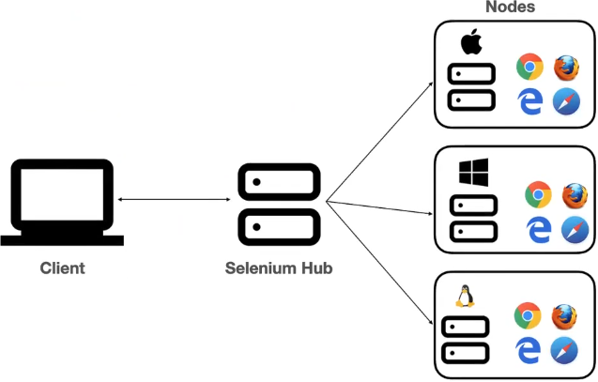

We can setUp Grid environment in to 2 different modes

1) Stand alone

In that type we have hub and node concept. This setUp is done on a single machine. We use one machine as a hub and as a node

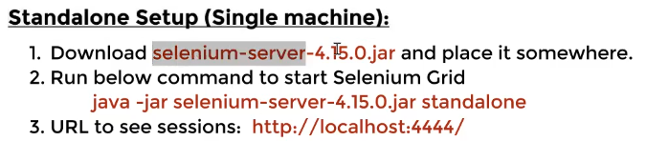

Ранить команду надо в консоли.

2) Hub and node setup.

